**Alekhya Krishna Balivada Python Day 4 Assessment-4(15-12-2023)**

**Data Structures:** Data structures are containers that organize and group data according to type. The data structures doffer based on mutability and order..

* The basic python data structures in python include List, Set, Tuple and Dictionary. Each of the data structures is unique in its own way.

**2. Sets:** Sets are used to store multiple items in a single variable. Which is represented as { }.

* A set is a collection which is unordered*,*unchangeable\**,* andunindexed*.* No duplicate members.
* Set items are unchangeable, but you can remove items and add new items.
* Duplicate values will be ignored in the set.
* Set items can be of any data type.

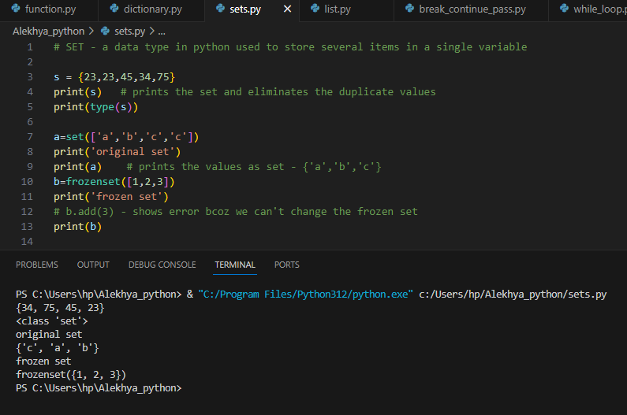 **Frozen set:** An immutable version of a python set objects is a frozen set. The parts of set can be changed at any moment but the elements in frozen set can’t be changed.

**Set Methods:**

1. Add( ) : Adds an element to the set.
2. Clear( ) : Clears all the elements in the set.
3. Copy( ) : Returns a copy of the set.
4. Pop( ) : Removes an element from the set
5. Remove( ) : Removes the specified element.
6. Union( ) : Returns a set containing the union of sets.
7. Update( ) : Update the set with another set.
8. Difference( ) : Returns a set that is difference between 2 sets.
9. Difference_update( ) : Removes the items in this set that are also included in another set.
10. Discard( ) : Remove the specified item.
11. Intersection( ) : Returns a set that is intersection of two or more sets
12. Intersection_update( ) : Removes the items in the set that are not present in the other.
13. IsDisjoint( ) : Returns whether 2 sets have intersection or not.
14. Issubset( ) : Returns Whether another set contains this set or not.
15. Issuperset( ) : Returns whether this set contains another set or not.
16. Symmetric_difference( ) : Returns a set with the symmetric difference of 2 sets.
17. Symmetric_difference_update( ) : Inserts the symmetric differences from this set.

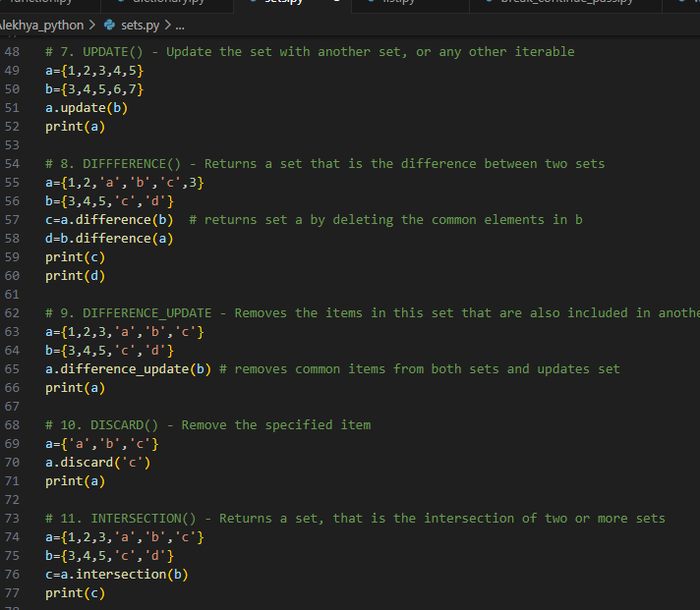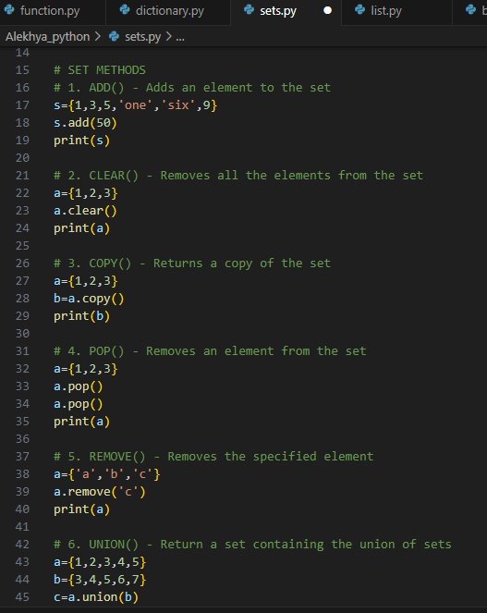

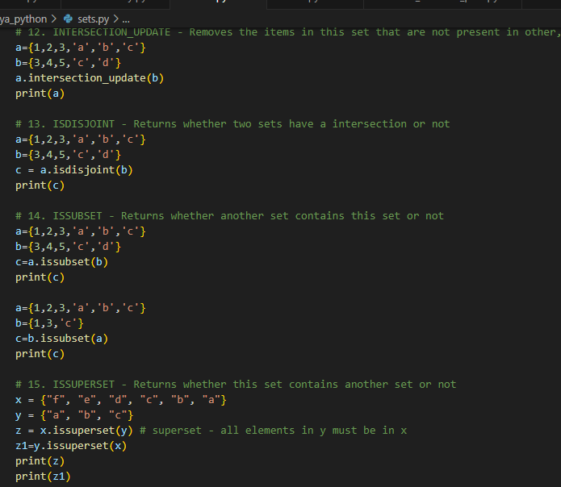

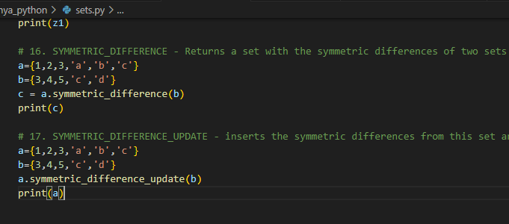

**Function :** A function is a block of code which only runs when it is called. You can pass data, known as parameters, into a function. A function can return data as a result. In Python a function is defined using the **‘def’** keyword.

Types of Arguments : 1. Position Arguments

2. Keyword Arguments

3. Default Arguments

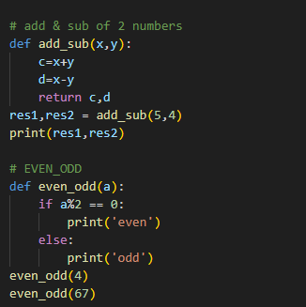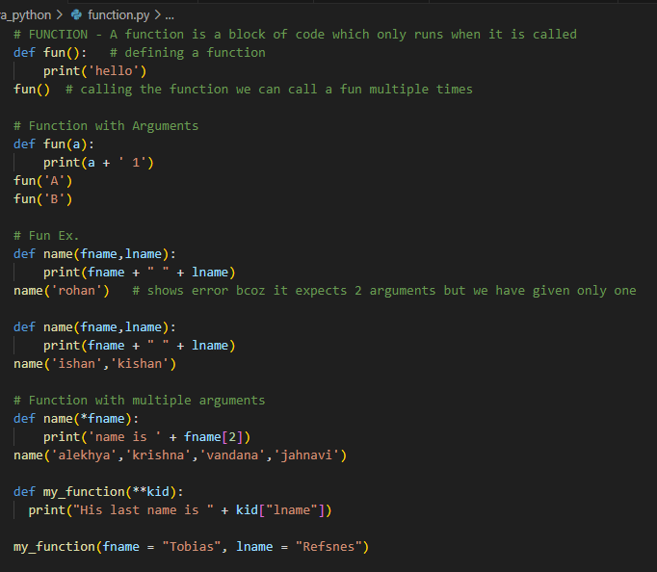 4. Arbitrary Arguments

